XX1805

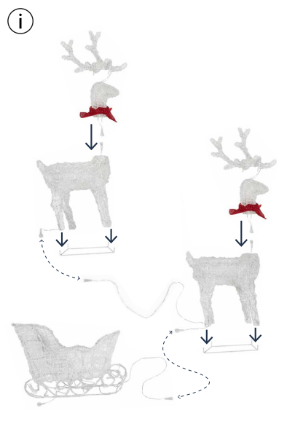

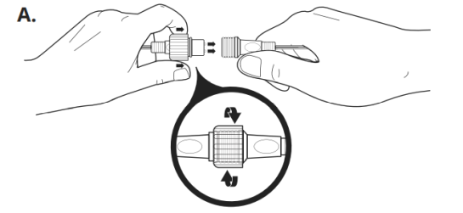

1. Position all parts as shown
2. Secure each hoof into position on the stand
3. To illuminate the lights locate the connector in the head and the body and connect together (diagram A).
4. Secure the head into position by inserting the two metal posts into the corresponding metal slots on the neck.
5. Slot the antlers into position by inserting the metal posts into the corresponding metal slots.
6. If supplied with cable ties, these may be used to further secure body parts to one another once assembled.
7. Connect your Reindeer lights together and then connect to the sleigh (diagram A).
8. Connect your lights from the back of the Sleigh to the end of the battery box lead wire (diagram A).
9. Secure the stand into position using the metal pegs supplied.
10. Tie the red bows around the neck.